1. **Enable macros when the Message Bar appears**

When you open a file that has macros, the yellow message bar appears with a shield icon and the Enable Content button. If you know the macro, or macros, are from a reliable source, use the following instructions:

* On the **Message Bar**, click **Enable Content**. The file opens and is a [trusted document](https://support.office.com/en-us/article/trusted-document-cf872bd8-47ec-4c02-baa5-1fdba1a11b53).
* The following images are an example of the Message Bar when macros are in the file.

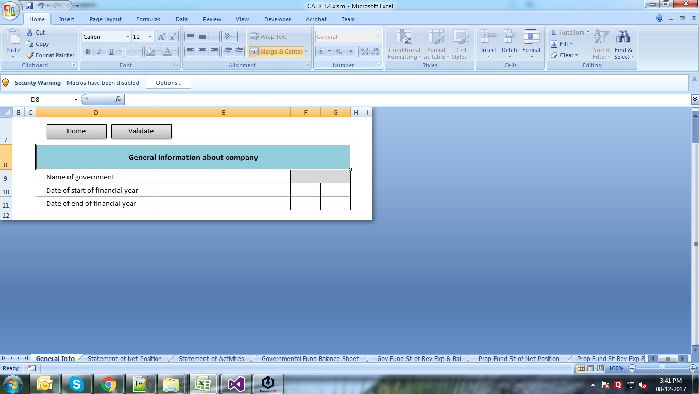

`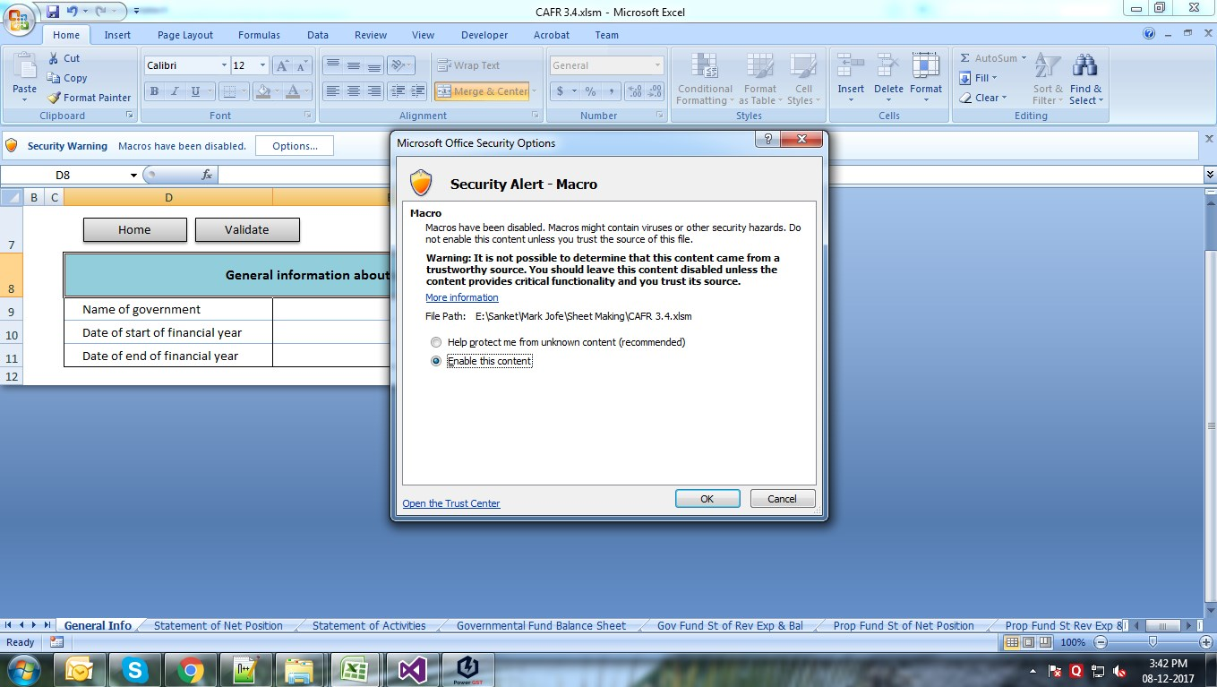

1. Rules :

* All fields are mandatory.
* Select start date and date from drop down in general information.
* Validate all the sheets before generate XML.

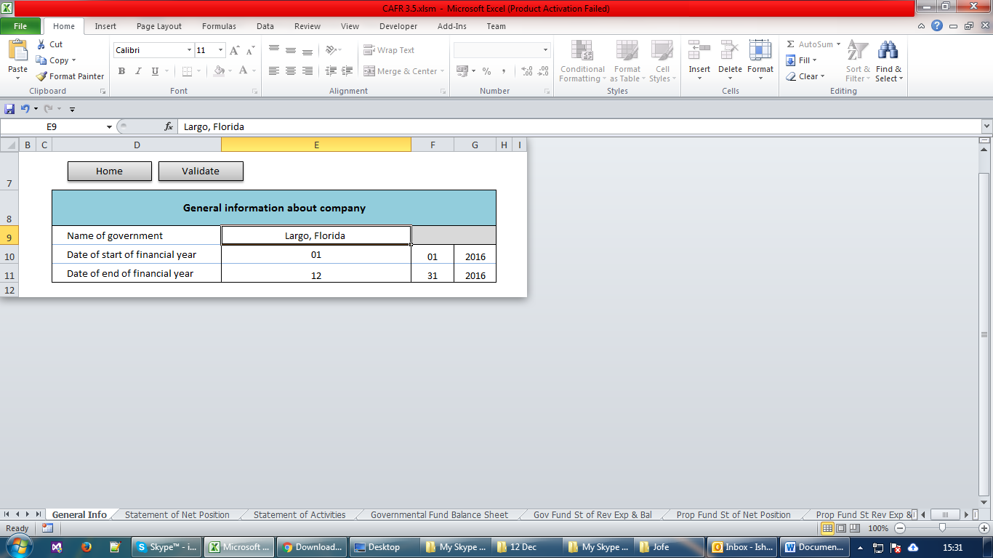

1. If we have funds name variables and we can add maximum 10 variables in the excel file.

Sheet Name:

* Governmental Fund Balance Sheet
* Gov Fund St of Rev Exp & Bal
* In the excel sheet , there is one **‘+’** Sings on the top of Colum M.

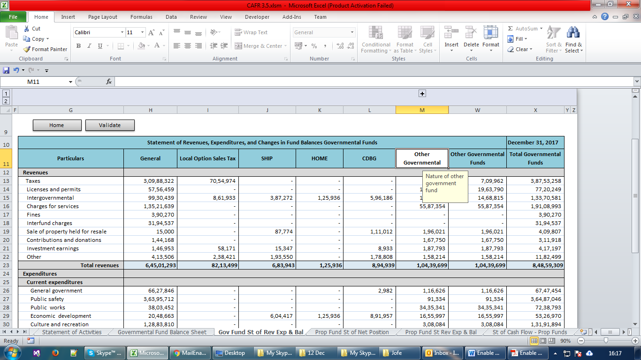

* Just click on that sings than we can see there others columns are now visible:

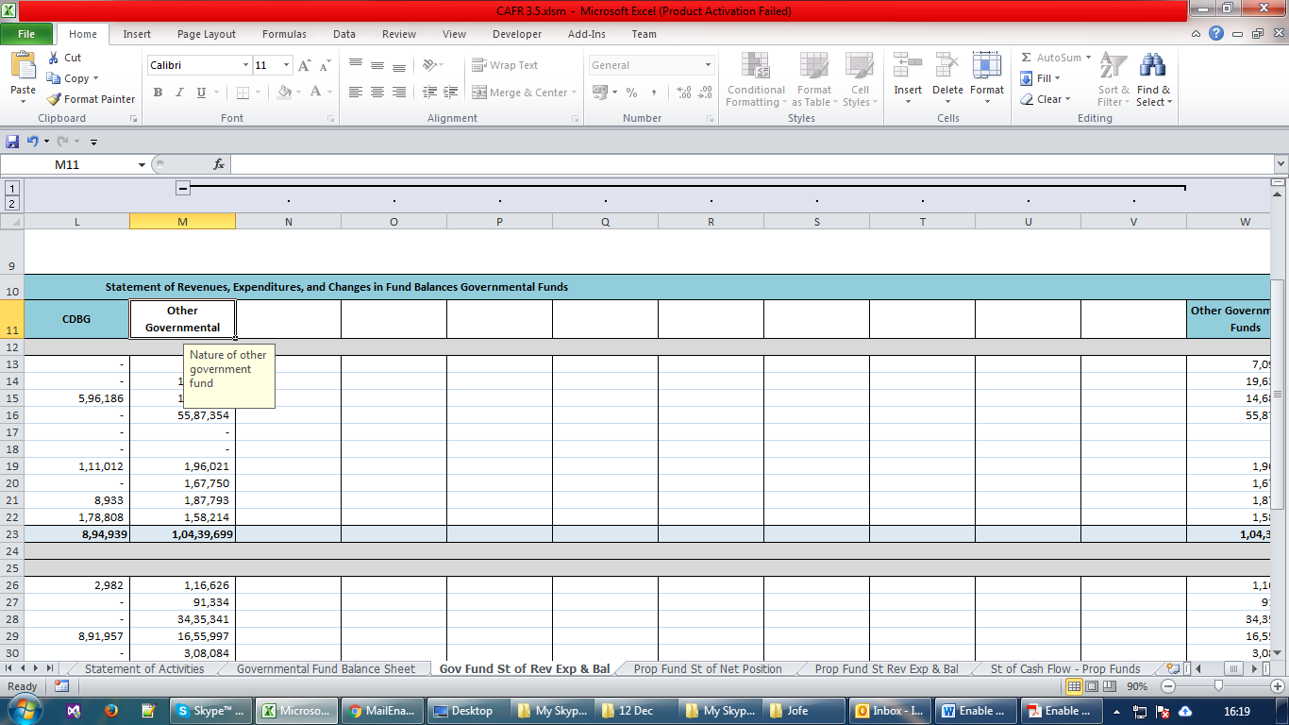

* In row no. 11 , we will mention nature of other government fund and its mandatory for both sheet.
* In the “Gov Fund St of Rev Exp & Bal” sheet , nature of other government fund comes automatically form sheet “Governmental Fund Balance Sheet”.
* All fields are mandatory in the all sheets.

1. Validate and generate XML:

* Click on the home button and click on validate all sheet.

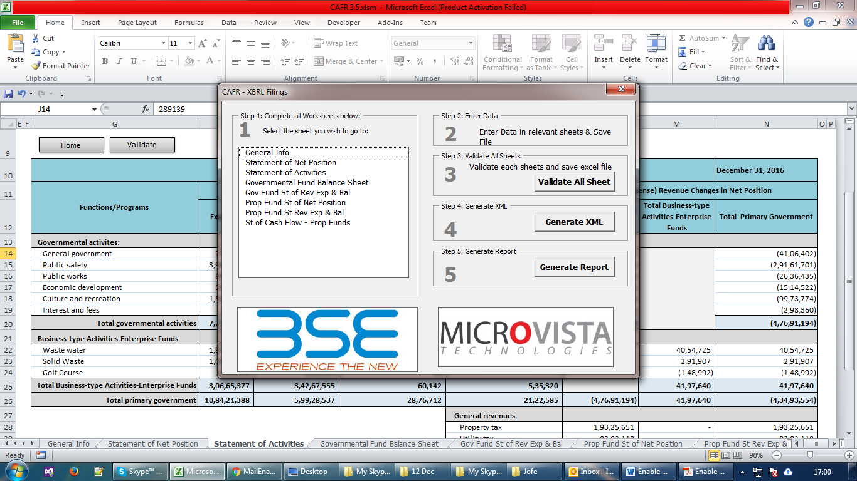

* Once you validate all the sheets and click on Generate XML button :



* Save the XML into taxonomy folder:

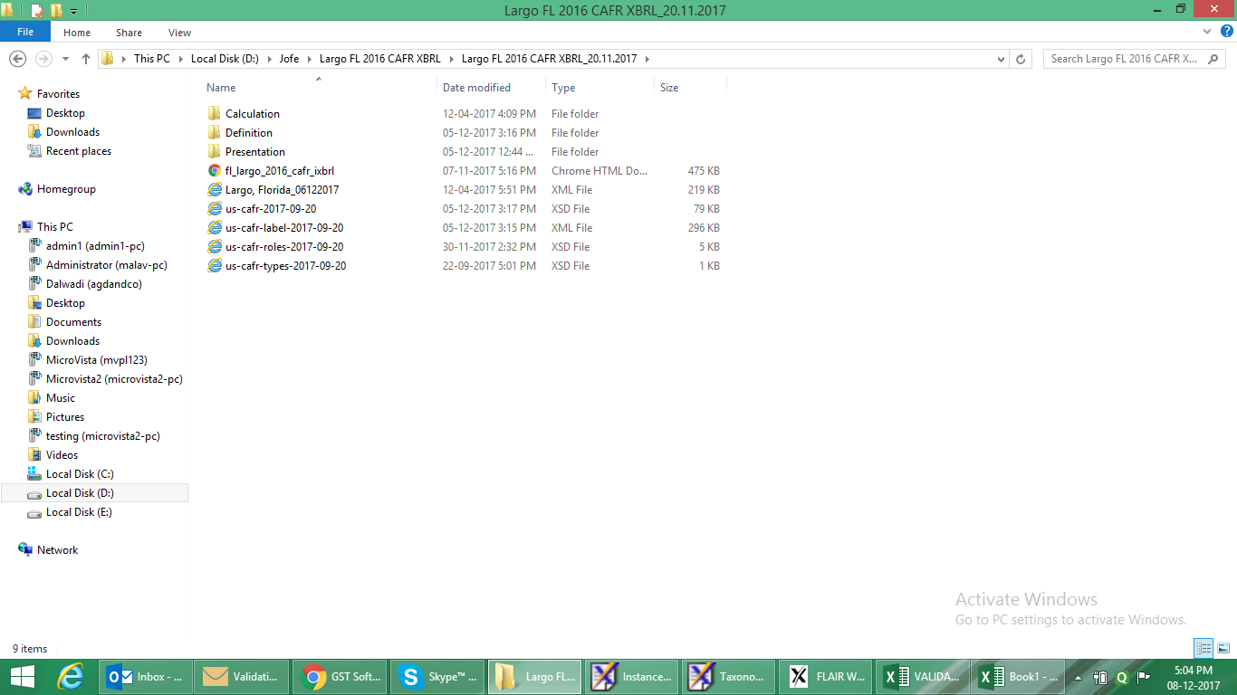

* Validate the XML into Arelle.